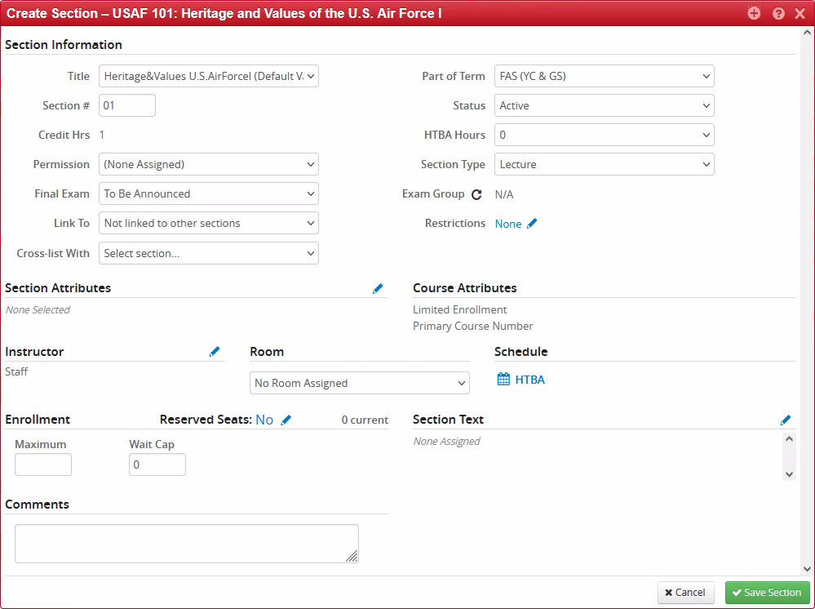
Section Information
- Title: This field defaults to the course’s short title.  - The title may be changed in limited instances:  - Discussion Section titles  - Certain departments with access granted to change titles | - Part of Term: This field defaults to FAS (YC & GS).  - This field does not typically need to be changed, although certain departments have access to choose between either FAS First Half-term and FAS Second Half-term.
Section #: This field will default to 01 when you add your first offering and will automatically increase with each subsequent offering.  - Discussion Sections: Discussion section numbering conventions use alphabetical characters instead of numbers. When adding discussion sections, an alphabetical character must be manually assigned to each discussion section, using the characters in alphabetical order. | Status:  - Active: The course is offered.  - Cancelled: Plans have changed for an offered course. Registration is not possible but the course will still be published in Yale Course Search with the Cancelled status.  - Not offered: A course was offered erroneously. The course is cancelled and removed from Yale Course Search.  - Omit from OCI: Administrative use only. An error will appear if attempting to use this option.
Credit Hrs: This field is not editable. | HTBA Hours: Indicates how many hours of required learning (outside of the standard class time) will be announced at a later date. Hours To Be Announced (HTBA).
Permission: This field applies only to Yale College student registration even though the field is available for all courses.  - The default is (None Assigned). This option allows students to freely enroll until the enrollment has reached the maximum, set in the Enrollment area of this screen.  - Instructor Permission Required will not allow a student to enroll without the instructor’s approval, given through Yale Course Search. This option is not limited by the maximum enrollment number.  - Instructor Permission Required cannot be used in conjunction with a Wait Cap setting greater than zero, in the Enrollment area of this screen. | Section Type: This field generally corresponds to the course format listed in CIM. If a course has discussion sections, another option appears in this menu.
Final Exam: The default is To Be Announced.  Yes, Final during Finals Week—This option indicates the course will have a final exam, and the exam will be during Finals Week. WEN will automatically calculate the day and time of the final exam.  No, Not during Finals Week—This option indicates one of the following scenarios:  - The course does not have a final exam.  - The course does have a final exam but the exam will not be held during Finals Week.  - The course has a take-home final exam.  See the Final Examination Schedules page for more information. | Exam Group: This field automatically updates based on the options selected in the Final Exam field. This field is not editable.
Link To: This field is for linking discussion sections and lectures.  See the Creating Discussion and Lab Sections document for additional information. | Restrictions: Use this option to limit registration. Restrictions can be set to include or exclude students within defined restriction types:  - Classification: The student’s class year  - Field of Study – Major: The student’s chosen Major  - Level: The school in which the student is enrolled
Cross-list With: This field is used to cross-list courses across different schools, including Yale College and Graduate School cross-listings.
- This field cannot be used until all courses in the cross-listing have been offered.

Section Attributes | Course Attributes
This area will display attributes inherited from the Course Attributes (see the column on the right) after the course has been pushed to Banner.  - Inherited attributes cannot be changed but attributes may be added. | Course attributes come from entries in CIM and are not editable in WEN.

Instructor | Room | Schedule
Assign instructors for the course offering.  - The default entry is Staff. Search for and add one or more instructors.  - Assign a role to each instructor: Primary or Non-Primary.  - Only one instructor may have the Primary role and that role is responsible for entering grades at the end of the term. | Assign a room for the course offering.  - Some departments will have classrooms in the list.  - The default selection is No Room Assigned. Keep this option if the course offering has no Schedule (see the column to the right).  - If the course offering has a Schedule, select either the General Assignment Room or a room in the list.  - If General Assignment Room is selected, the University Registrar’s Office will assign a room and the assignment will be reflected in this field. | Set a meeting pattern for the course.

Enrollment and Reserved Seats | Section Text
Maximum: Set the maximum number of students allowed to enroll.  - The number is a hard limit for Yale College and Graduate students combined.  - The Maximum may be adjusted later if desired.  Wait Cap: A number in this field enables waitlisting for the course and sets the number of seats allowed to be waitlisted.  - If the Maximum enrollment has been met, students can choose to be placed on the waitlist. As enrolled students drop the course, the registration system will automatically send offers to enroll to waitlisted students on a first-come-first-serve basis. Instructors cannot intervene with the waitlist process.  - If there are students on the waitlist, do not reduce the Wait Cap number without first consulting the University Registrar’s Office.  - Note for discussion/lab sections: The default Wait Cap for discussion sections is 0 (zero). Departments may opt to add the waitlist function to discussion/lab sections by entering a number in the Wait Cap field.  - A Wait Cap setting greater than zero cannot be used in conjunction with the Instructor Permission Required setting in the Permission area of this screen.  Reserved Seats: This field allows setting aside seats for specified student types. Those seats cannot be taken by students outside of the specified type.  - Reserved seats cannot be used for cross-listed courses. | This field allows adding information beyond the course description text and is published in Yale Course Search.

Comments
Text entered in the Comments field is for departmental use only. This information is not published in Yale Course Search nor monitored by the University Registrar’s Office.
- Recommendation for discussion sections: Include the name of the assigned Teaching Fellow and information about any back-to-back discussion sections offered.

